**A**

**PROJECT REPORT**

**ON**

**Paint Shop Management**

**(Windows Application)**

**SUBMITTED**

**TO**



**BHARATI VIDYAPEETH PUNE**

**IN THE PARTIAL FULFILLMENT OF**

**BACHELOR OF COMPUTER APPLICATIONS**

**SEMESTER-VI (2021 - 22)**

**BY**

**Ms. Harsha Harkut**

**Mr. Adil Patel**

**Mr. Athar Patel**

**UNDER THE GUIDANCE OF**

**Prof D. D. Mhetre.**

**THROUGH**

**DIRECTOR**

**BHARATI VIDYAPEETH, PUNE**

**ABHIJIT KADAM INSTITUTE OF MANAGEMENT AND**

**SOCIAL SCIENCES, SOLAPUR**



**BHARATI VIDYAPEETH**

**DEEMED UNIVERSITY, PUNE (INDIA)**

**ABHIJIT KADAM INSTITUTE OF MANAGEMENT AND SOCIAL SCIENCES, SOLAPUR**

**Vijapur Road, Jule Solapur, Solapur – 413 004**

[**http://akim.bharatividyapeeth.edu**](http://akim.bharatividyapeeth.edu)

**0217 – 2302016/2341353 e-mail:** [**akim@bharatividyapeeth.edu**](mailto:akim@bharatividyapeeth.edu)

|  |  |  |
| --- | --- | --- |
|  | Name of the Student / PRN | Ms. Harsha Harkut PRN:- 1923100277  Mr. Adil Patel PRN:- 1923100268  Mr. Athar Patel PRN:- 1923100322 |
|  | Batch | 2021-22 |
|  | Subject No. & Name | Major Project |
|  | Name of Project Guide | Prof. D. D. Mhetre. |
|  | Project Title | Paint Shop Management |
|  | Project Duration | 3 Months |



**BHARATI VIDYAPEETH (DEEMED TO BE) UNIVERSITY, PUNE**

**ABHIJIT KADAM INSTITUTE OF MANAGEMENT AND SOCIAL SCIENCES, SOLAPUR**

**C E R T I F I C A T E**

This is to certify that **Mr. Athar Patel** having Exam Seat No._________________ is bonafide student of this Institute studying in **BCA SEM–VI (2021-22)** have completed the project report entitled **“Paint Shop Management”** for the partial fulfillment of the requirement of **B.C.A**. submitted to **BHARATI VIDYAPEETH UNIVERSITY, PUNE.** He has carried out the work satisfactory.

Place: Solapur

Date:

**Dr. S. B. Sawant**

**Director**

**Abhijit Kadam Institute of Management**

**and Social Sciences, Solapur**



**BHARATI VIDYAPEETH (DEEMED TO BE) UNIVERSITY, PUNE**

**ABHIJIT KADAM INSTITUTE OF MANAGEMENT AND SOCIAL SCIENCES, SOLAPUR**

**C E R T I F I C A T E**

This is to certify that **Mr. Athar Patel** having Exam Seat No._________________ is bonafide student of this Institute studying in **BCA SEM–VI (2021-22)** have completed the project report entitled **“Paint Shop Management”** for the partial fulfillment of the requirement of **B.C.A**. submitted to **BHARATI VIDYAPEETH UNIVERSITY, PUNE.** He has carried out the work satisfactory.

Place: Solapur

Date:

**Dr. A. B. Nadaf**

**HOD, Department of Computer Application**



**BHARATI VIDYAPEETH (DEEMED TO BE) UNIVERSITY, PUNE**

**ABHIJIT KADAM INSTITUTE OF MANAGEMENT AND SOCIAL SCIENCES, SOLAPUR**

**C E R T I F I C A T E**

This is to certify that **Mr. Athar Patel** having Exam Seat No.__________________ is bonafide student of this Institute studying in **BCA SEM–VI (2021-22)** have completed the project report entitled **“Paint Shop Management”** for the partial fulfillment of the requirement of **B.C.A.** submitted to **BHARATI VIDYAPEETH UNIVERSITY, PUNE.**

He has carried out the work satisfactory.

Place: Solapur

Date:

**Prof. D. D. Mhetre**

**Project Guide (Internal) External Examiner**

**D E C L A R A T I O N**

To,

The Director,

Bharati Vidyapeeth University,

Abhijit Kadam Institute of Management

And Social Sciences, Solapur – 413004

Respected Sir,

I undersigned hereby declare that the project report entitled **“Paint Shop Management**” written and submitted under the guidance of **Prof.** **D.D. Mhetre,** it’s my original work. The empirical findings in this project are based on the data collected by myself while preparing this project. I have not copied from any other project report.

I understood that, any such copying is liable to be punished in a way the University authorities may deem fit.

Place: Solapur

Date:

**Ms. Harsha Harkut**

**Mr. Adil Patel**

**Mr. Athar Patel**

**ACKNOWLEDGEMENT**

The happiness of anything depends on what we give more than what we get. I would like to give the words of thanks, but the words are not enough to express my deep sense of gratitude to many persons who spread their time and efforts during the course of study work without their whole hearted assistance and co-operation the project won’t be successful

I would like to give special thanks to our **Director Dr. S.B. Sawant** for giving an opportunity to complete my project.

I got the opportunity to express my sincere thanks to project guide **Prof.** **D.D. Mhetre** for their valuable guidance and contribution in preparing the project.

I am especially thankful to **Dr. A.B Nadaf** for his valuable guidance and contribution in preparing the project.

I also, thank to my classmates everyone of my family and all the people who helped me directly and indirectly to complete this project.

**Ms.Harsha Harkut**

**Mr. Adil Patel**

**Mr. Athar Patel**

**INDEX**

|  |  |  |
| --- | --- | --- |
| 1 | Introduction to the Project | 9 |
| 2 | Objectives of the Project | 11 |
| 3 | Feasibility Study   * + Technical feasibility   + Economical feasibility   + Operational feasibility | 12 |
| 4 | Project Work Plan | 13 |
| 5 | Configuration Needed   * + Hardware Specification   + Software Specification   + Technology Used | 14 |
| 6 | Object Oriented Analysis / Structured Analysis   * + DFD Diagram   + ER Diagram | 16  18 |
| 7 | Database design | 19 |
| 8 | Screens layout | 22 |
| 9 | Reports | 26 |
| 10 | Testing | 28 |
| 11 | User manual | 29 |
| 12 | Limitations | 30 |
| 13 | Suggested References | 30 |

INTRODUCTION

* 1. **Existing System**

In today’s dynamic and highly competitive market place, proposed system will help to maintain details in well-formed structure. In existing system all work done manually. Records are maintained using registers, but at present, computers are becoming part of every activity in organization. The more common and obvious application are business applications.

Report wizard files there for well-structured reports are generated .The project entitled with **“Paint Shop Management”** is developed for solving different real life problem. One of the common Real Life Problem is to Store and maintain Records and the other is to find out the Records. So with the time, the system must also fit into a competitive environment and must be very easy to use. Above all, the main goal of computer based information system is to speed up the processing. And that is the reason why the new system was proposed.

* The operation of Paint Shop Management is now maintained in the manual system.
* The operation is tedious, time consuming and space consuming.
* It creates room of errors as the date is entered manually by the person.
* It includes the risk of the documents being lost over years and maintenance of the records is difficult.
* The data recorded during testing or while acquiring the details of different aspects of Paint Shop Management is not accurate and precise.
* Maintaining the stock of different items and the daily transactions without computerization also poses a challenge.

**1.2) Proposed System:**

The aim of proposed system is to develop a system of improved facilities. The proposed system can overcome all the limitations of the existing system. The system provides proper security and reduces the manual work.

This system is interactive and user-friendly Desktop application. The application is developed using Microsoft Visual Studio 13 as a front end and MS SQL Server as a back end to accommodate all the future of GUI technology such as Text Box, Combo Box Buttons which will be multi user system.

In today’s dynamic and highly competitive marketplace, this system will help to achieve productivity, profitability, and growth.

* Security of data.
* Ensure data accuracy’s.
* Minimize manual data entry.
* Minimum time needed for the various processing.
* Greater efficiency.
* Better service.
* User friendliness and interactive.
* Minimum time required.

**1.3) Scope of Project:**

It may help collecting perfect management in details. In a very short time, the collection will be obvious, simple and sensible. It will help a person to know the management of passed year perfectly and vividly. It also helps in current all works relative to Paint Shop Management. It will be also reduced the cost of collecting the management & collection procedure will go on smoothly. Our project aims at Business process automation, i.e. we have tried to computerize various processes of Billing System

* In computer system the person has to fill the various forms & number of copies of the forms can be easily generated at a time.
* In computer system, it is not necessary to create the manifest but we can directly print it, which saves our time.
* To assist the staff in capturing the effort spent on their respective working areas.
* To utilize resources in an efficient manner by increasing their productivity through automation.
* The system generates types of information that can be used for various purposes.
* It satisfy the user requirement
* Be easy to understand by the user and operator
* Be easy to operate
* Have a good user interface
* Be expandable.

**OBJECTIVE OF THE PROJECT**

The main objective of the Project on Paint Shop Management is to manage the details of Customer’s Registration, Product’s Registration, Receipt, and act. It manages all the information about Paint Shop. The project is totally built at administrative end and thus only the administrator is guaranteed the access. The purpose of the project is to build an application program to reduce the manual work for managing the Records, Registration, and Receipt. It tracks all the details about the Customer, Products, and stock details of products. Existing user has many problems while doing manually operations. This system is user friendly because proper system messages are displayed when any error comes.

* User needs to be registration before any operations.
* User must have validate information.
* Paint Shop also manage the Record details for Product Stock.
* It tracks all the information of Customers, Products, Suppliers, etc.
* Manage the information of Different Paints and accessories.
* Shows the information and description of the Products and Customer.
* To increase efficiency of managing the Records of Customers and Products.
* Manage the information of Paint Shop.
* Deleting, Adding new records and updating existing Records, etc. are the features which results in proper resource management of Paint Shop.
* Report Generation.
* Faster response.

**FEASIBILITY STUDY**

**Introduction:**

The preliminary investigation tells us whether the system that we are developing is practical or not. The feasibility study helps in that matter. Feasibility study is a very important stage in the system development. It helps to obtain an overview of the problem and to get rough assessment of whether feasible solutions exist. It can define problems, objectives involved in the project.

1. **Technical Feasibility:**

Technical feasibility is carried out to know whether the new system can be done with present equipment, existing software technology. All the present technologies, whether those are sufficient or not to develop new system is decided Ideally, the system should be compatible with the available Hardware and Software, or should work with very little up-gradation, to be considered as a feasible system.

1. **Economic Feasibility**: -

It is related to cost analysis. In the proposed system, there is no need to buy additional hardware or software. Banks only need to store documents and quick search out that Document which they wants to see. Manager need to update the Progress Report of documents.

1. **Operational Feasibility:**

Operational feasibility is carried out to see the effects after the system is implemented. This web site development system is very user friendly so user. Also provide easy and fast access to their reports

**Project Work Plan**

Schedule

|  |  |
| --- | --- |
| Task | To be completed by |
| Submission of Synopsis | February 18, 2022 |
| Approval of Synopsis | February 25, 2022 |
| Project Initiation | March 2, 2022 |
| Requirement Gathering and Analysis | March 9, 2022 |
| System Design | March 15, 2022 |
| Coding & Testing | March 22, 2022 |
| Documentation | May 10, 2022 |
| Submission of Project Report | May 18, 2022 |

**Detailed Description of the Work Completed**

Requirement Engineering

Following are the provided requirements.

1. Error Reduction
2. Saves Money
3. Saves Time
4. Increases Shop Performance
5. Security

Technical Environment

**Software Requirements**

|  |  |
| --- | --- |
| Type | Description |
| Front End Technologies | Microsoft Visual Studio 2013 |
| Operating System | Windows |
| Database | Microsoft SQL Server 2012 |

**Hardware Requirements**

|  |  |
| --- | --- |
| Type | Description |
| Processor | Dual Core Processor and above |
| RAM | 2 GB (Minimum) |
| Storage | 50 GB Free Space |

Methodology used

* Understanding the need of customer and shop owner.
* Drafting the Software Requirement Specification document.
* Designing the required documents such as ERD, DFD.
* Designing tables layouts.
* Developing the system, Testing & Maintenance.

Based on point’s selection, we have adopted Waterfall method.

Functional Requirements

|  |  |  |  |
| --- | --- | --- | --- |
| Module | Functionality | Requirement ID | Details |
| Access Control | User Authentication & Authorization | AC01 | Login to the system |
| Masters Management | | MM01 | Manage Customer data |
| MM02 | Manage Company Wise Product data |
| MM03 | Manage Product data |
|  | | MM04 | Manage Supplier data |
| Report Generation | | RG01 | Display Customer Report |
| RG02 | Display Product Report |
| RG03 | Display Invoice Report |

**DFD**

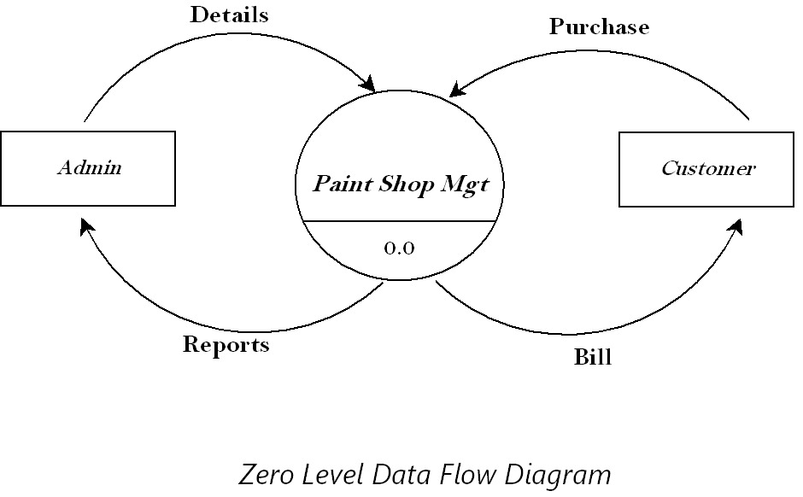

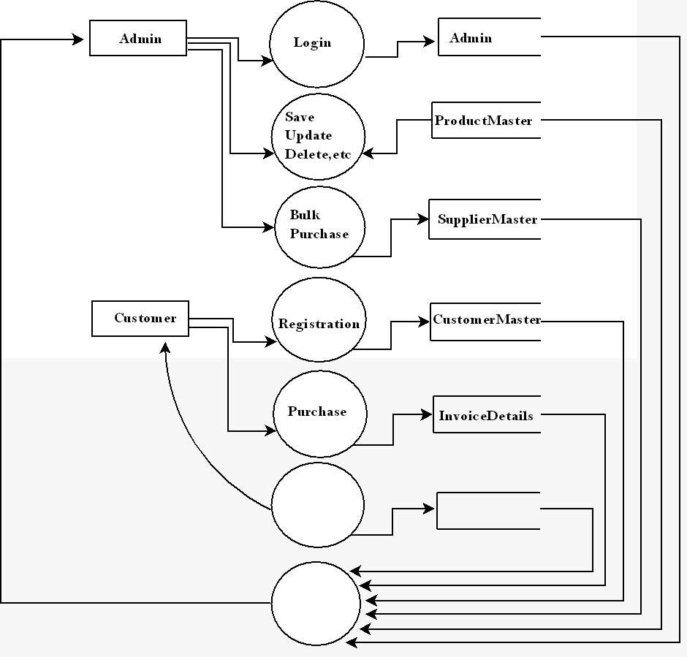

**Receipt InvoiceMaster**

**Reports**

*First level Data Flow Diagram*

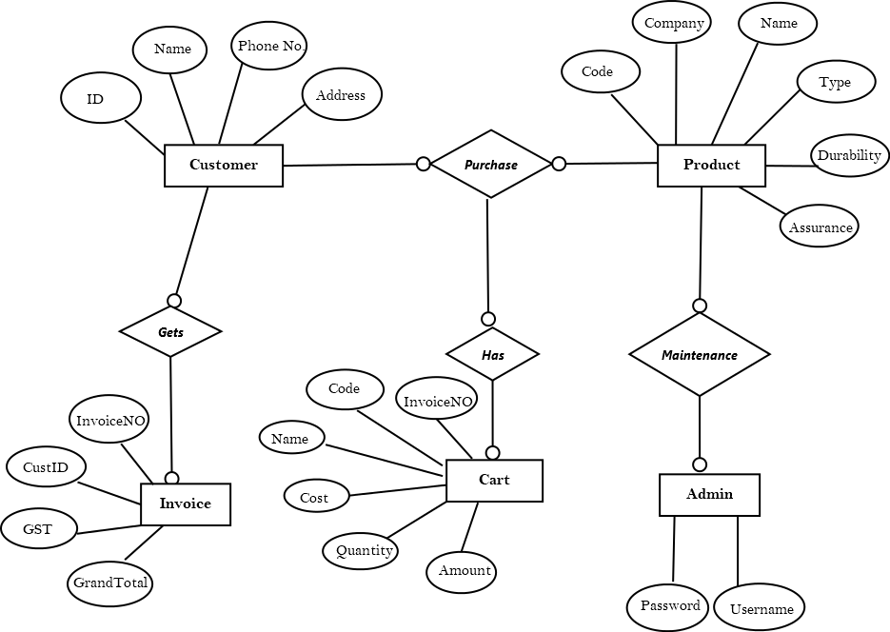*Entity Relationship Diagram*

**Data Base Design**

**Login Table:**

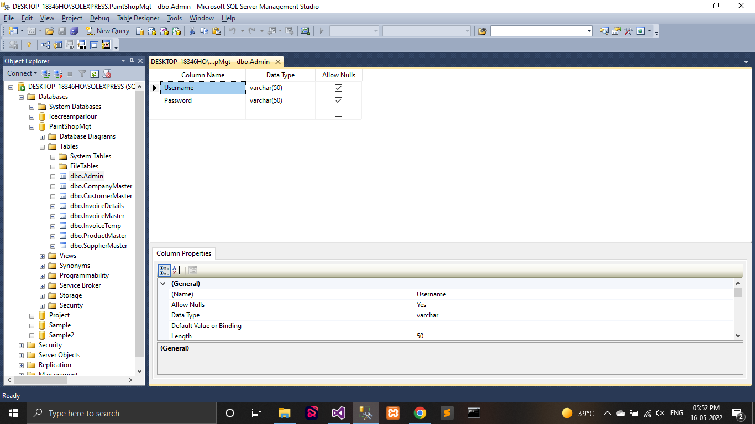

**Customer Table:**

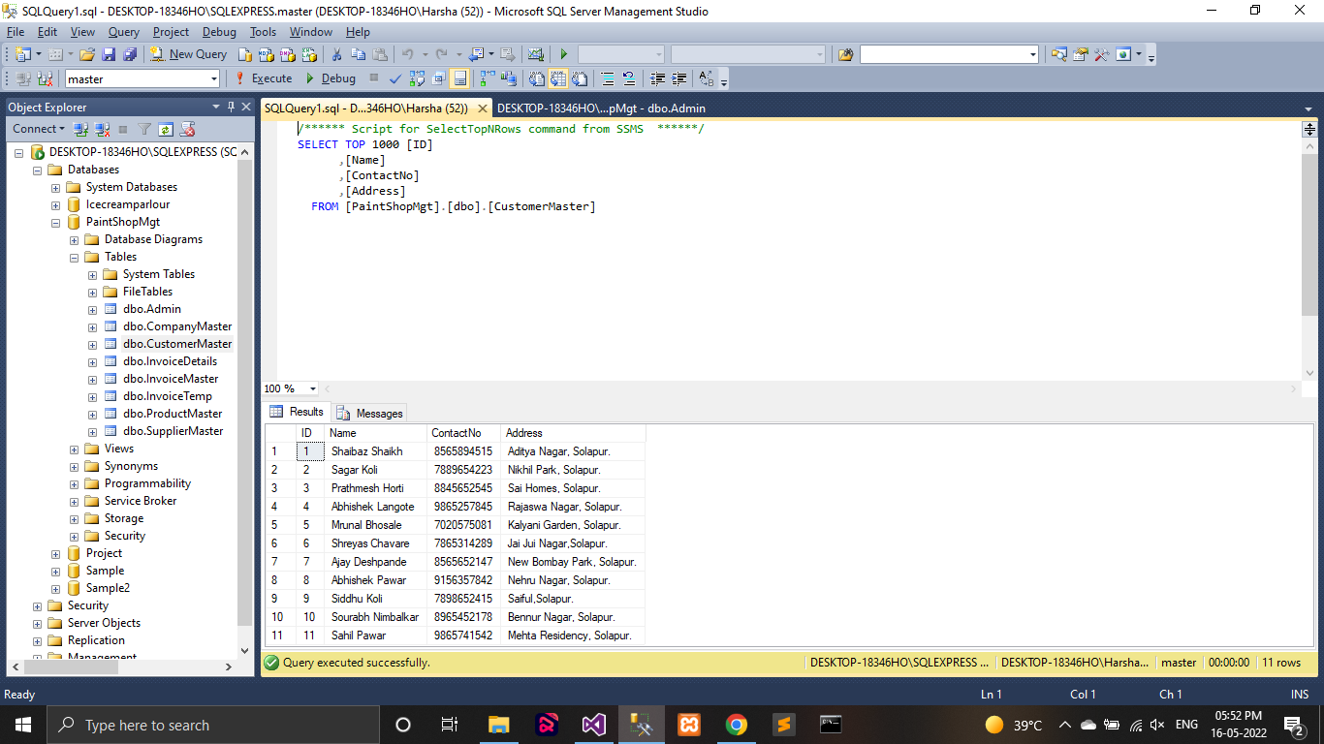

**Company Table:**

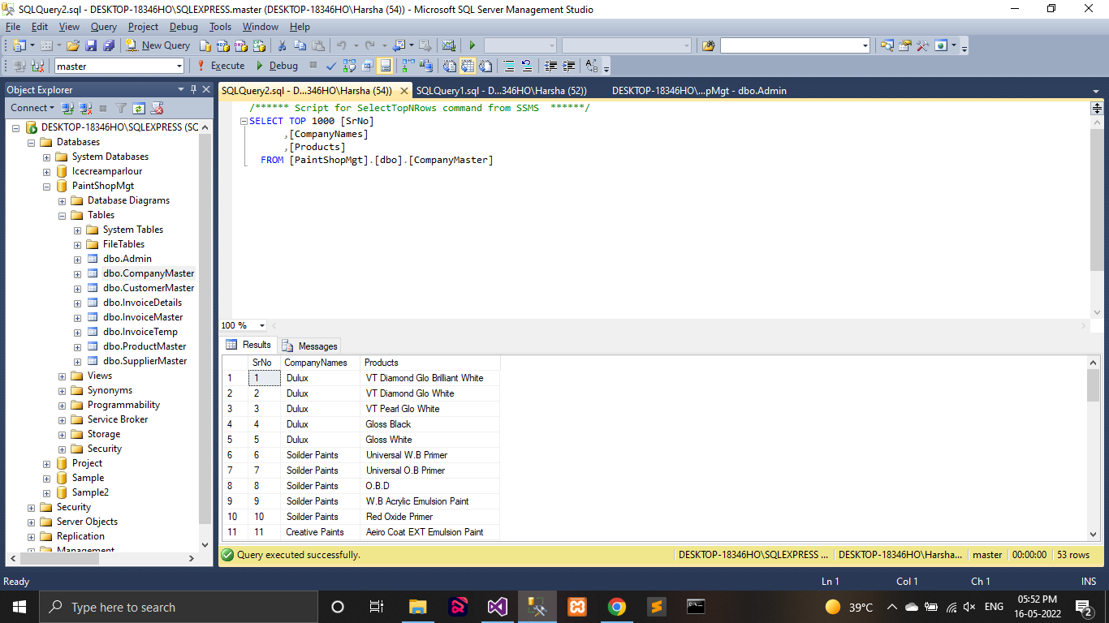

**Product Table:**

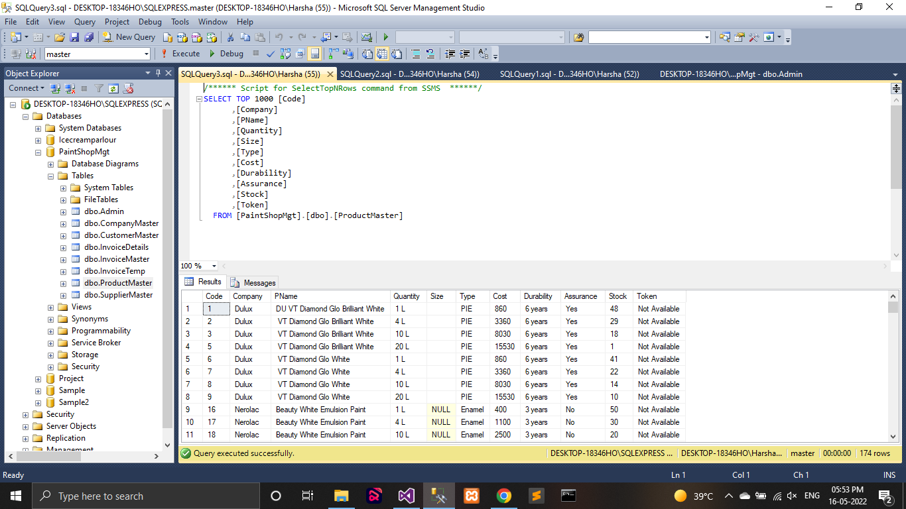

**Supplier Table:**

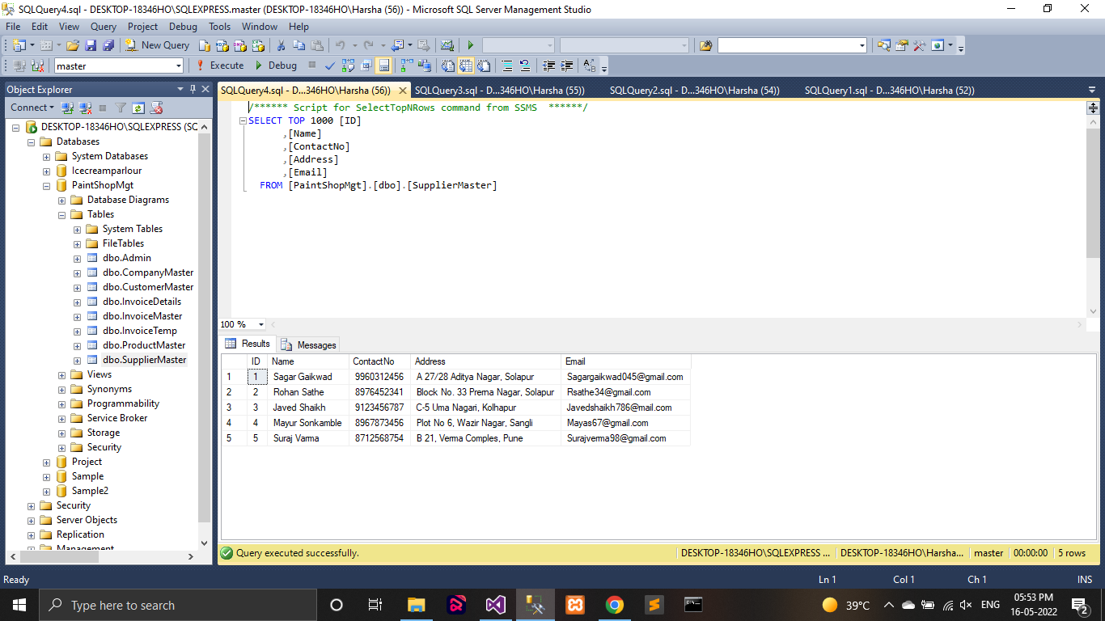

**Invoice Table:**

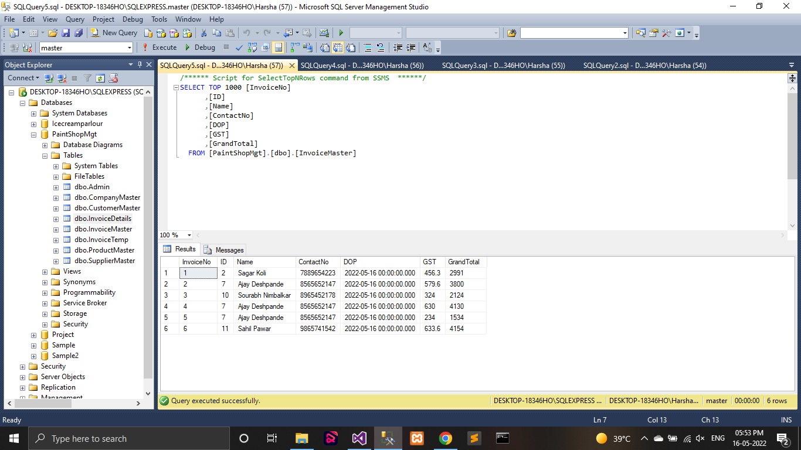

**Screen Layouts**

**Log In Form:**

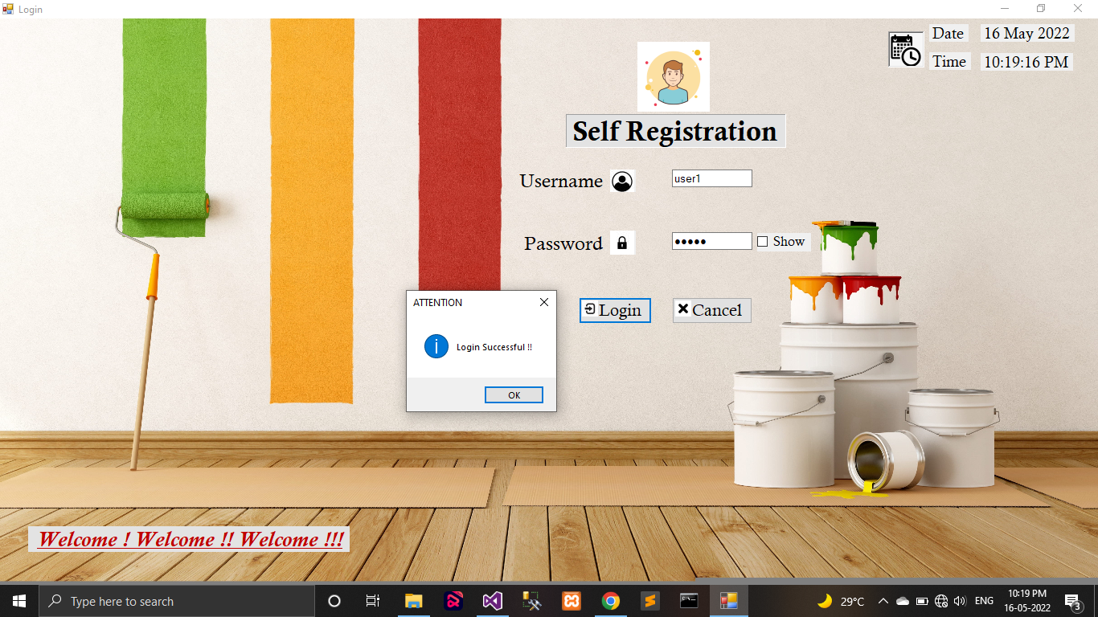

**Customer Details Form:**

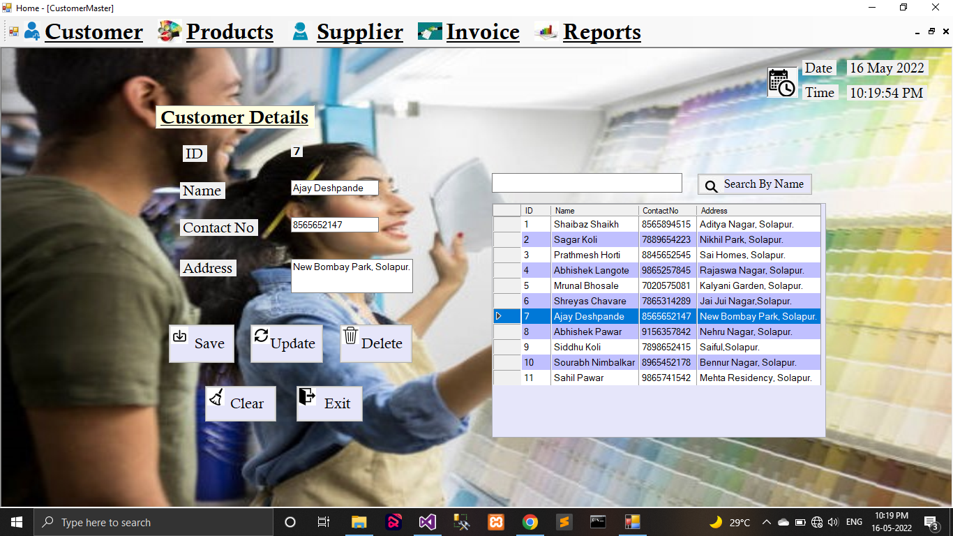

**Company Details Form:**

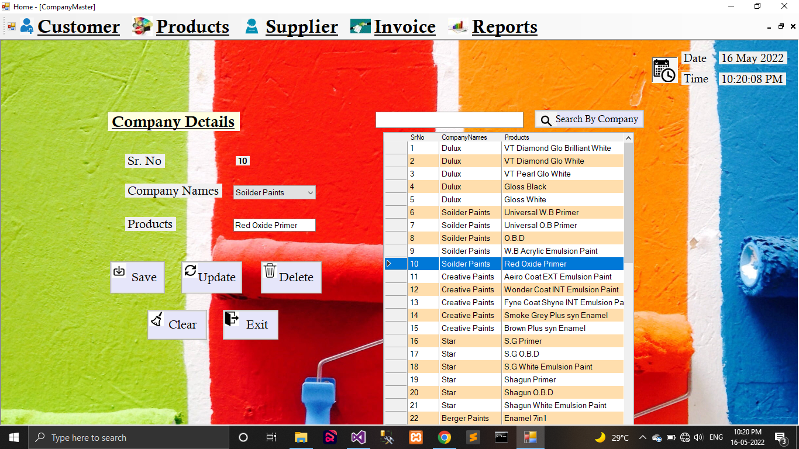

**Product Details form:**

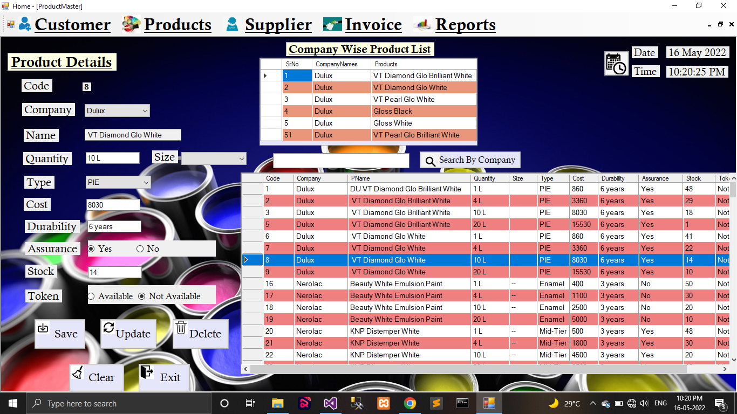

**Supplier Details Form:**

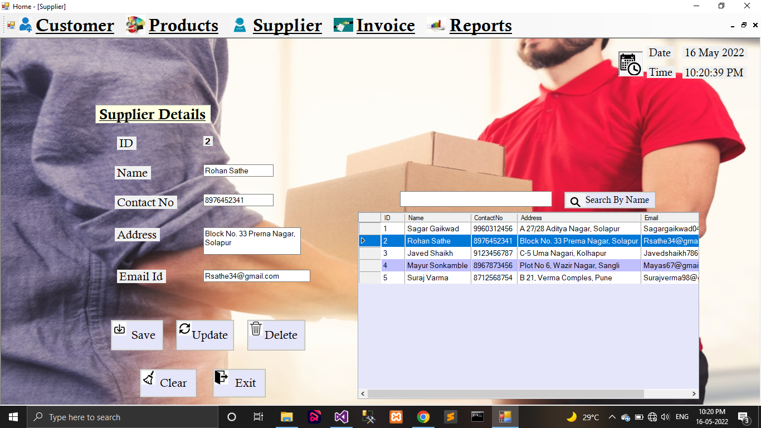

**Invoice Details Form:**

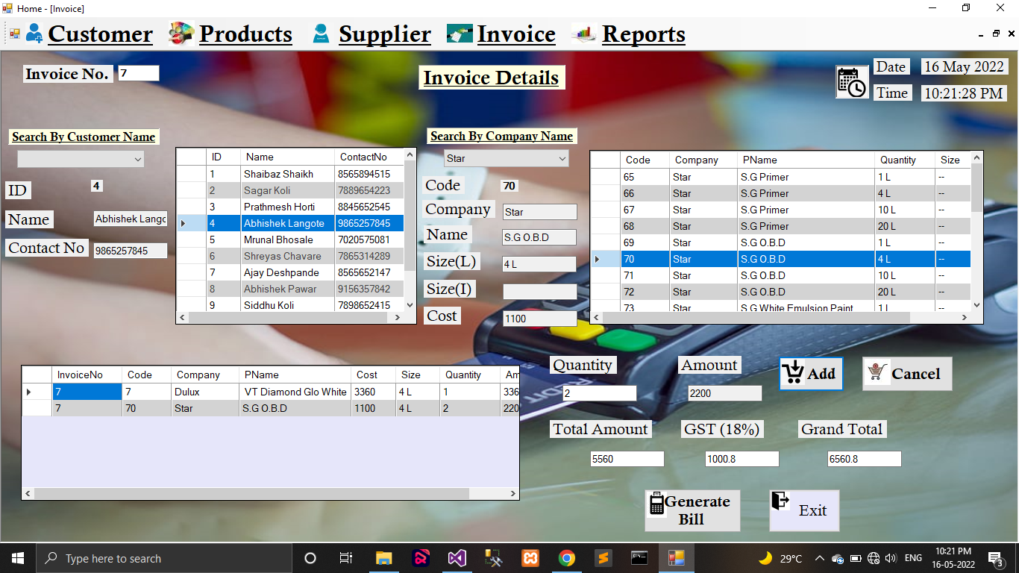

**Receipt Form:**

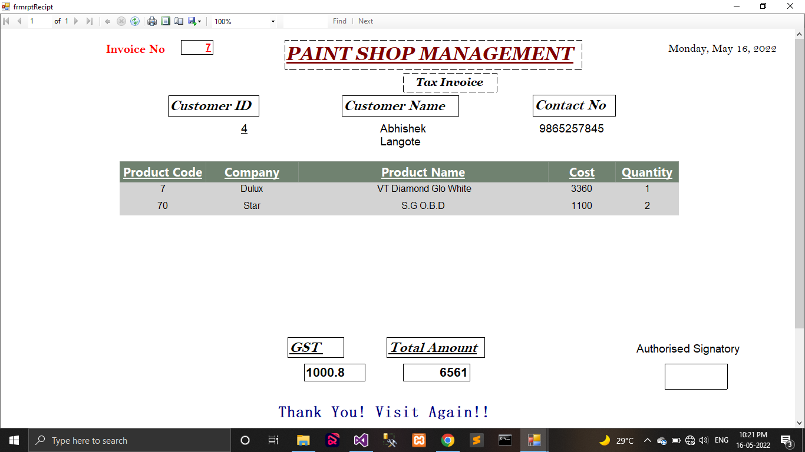

**Reports**

**Customer Report:**

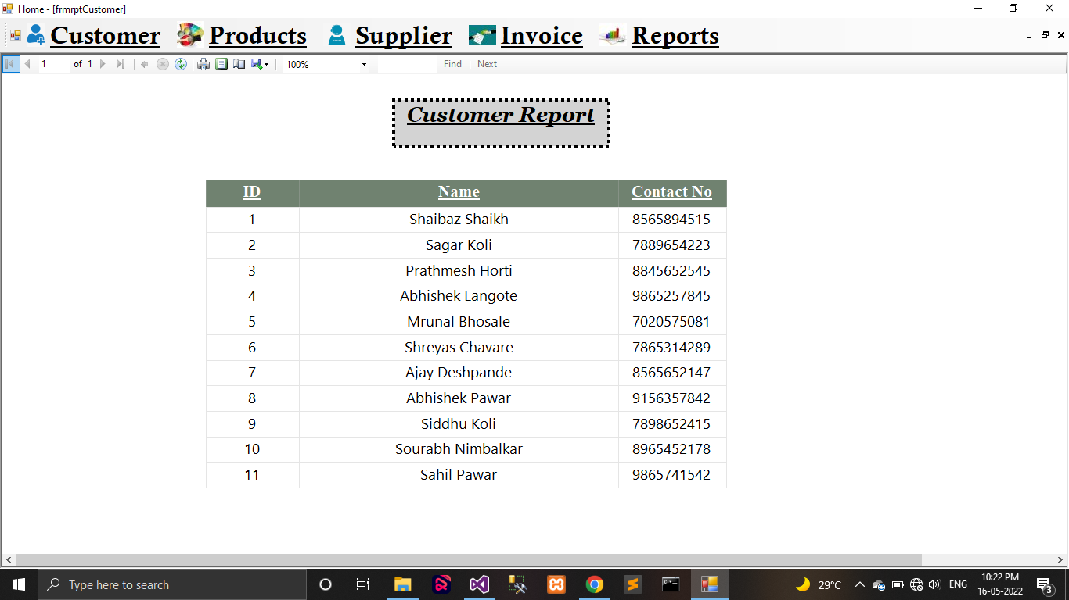

**Product Report:**

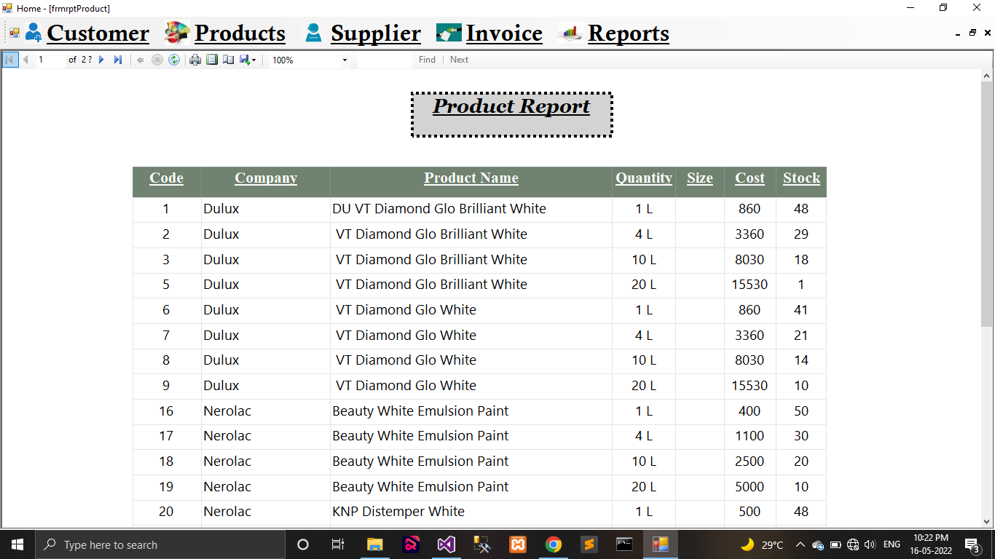

**Product Report:**

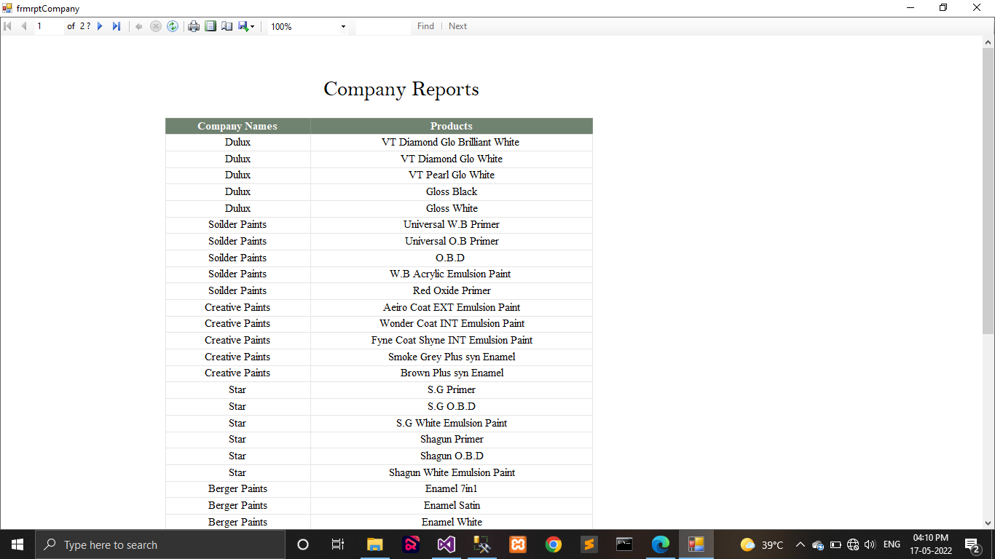

**Testing**

Testing is the process of execution of the program with explicit intention of searching for errors. A successful test is one that reveals errors in the system. Test cases are devised with normal input. The data is created with the express intent of determining whether the system will process it in the correct & pre-planned order. Testing is a step, which is actual usage of the system to remove the various discrepancies present.

System is neither designed as entire system nor tested as single system. System design, development, debugging and testing is carried out in modules. These modules are integrated to have entire fully fledged system.

**Unit Testing:**

In this testing the programs that form the system are tested. So this unit testing is also called “Program Testing”. The unit testing focuses on various modules, independent of another to locate errors. This enables the tester to detect flaws, inabilities and errors in coding and the logic that are present with the module alone. The test cases are also needed to test the range of values that are including both valid and invalid data.

**System Testing:**

System testing checks for the integration of each module in the system. It also searches for the discrepancies between the system and its original objectives, current specification, and system documentation. The primary concern is the compatibility of the individual modules.

**Actual Testing of System:**

The system is tested with these methods of testing. Testing is carried out using the test data and checked for discrepancies. The dummy data was provided in each & every possible way to ensure consistency of the system. The system with the validation at every stage handles all the data and also provides relevant message to the user in case of incorrect information.

**USER MANUAL**

This is manual working of the system. The steps are to be followed while working with the system.

**Login Page:**

It can be used for signing in from the application. Depending up on the user role i.e. Administrator or Dealer or Sales Person.

To login into system user must enter values of

* Username
* Password

**Home Page (Menu):**

1. Customer Registration
2. Product Registration
3. Supplier Registration
4. Invoice
5. Receipt
6. Report

**Customer Registration:**

In the Customer Registration form the admin has to fill the given necessary information and by clicking on the ‘SAVE’ button all the information is saved in the database.

**Product Registration:**

In the Product Registration form the admin has to fill the given necessary information and by clicking on the ‘SAVE’ button all the information is saved in the database.

**Supplier Registration:**

In the Supplier Registration form the admin has to fill the given necessary information and by clicking on the ‘SAVE’ button all the information is saved in the database.

**Invoice:**

In Invoice form details of customer and also details of products purchased by customer is saved and quantity of purchased product and their amount is stored. After that when admin clicks on ‘GENERATE BILL’ button the receipt will be created.

**Limitations**

The only limitation of this project is that it requires a user who have basic knowledge of computer and can operate basic features of computer.

**References:**

**Site**:

* [www.google.com](http://www.google.com)
* Tutorialspoint.com
* Stackoverflow.com